**May the force be with you...**

**FORCES ACTING BETWEEN MOLECULES**

**(Intermolecular forces)**

* **Molecule** is a group of atoms joined together by covalent bonds.
* Intermolecular forces are weak attractions that exist **between** molecules.
* The intermolecular forces determine the attractions **between** molecules and, hence, the amount of energy which needs to be used to separate them, i.e. to boil the substance.
* When a molecular substance is turned to a gas only intermolecular forces are broken **not** bonds.
* There are three varieties of intermolecular force.

**1. Dispersion (Van der Waals’) forces**

* Non-polar molecules have small, **temporary, fluctuating dipoles** due to random movement of electrons;
* A temporary dipole **induces the dipole on other molecule**.
* The larger the molecule - **greater number of electrons** - the larger temporary dipoles and so **greater attractive forces between molecules, which are van der Waals’ forces.**

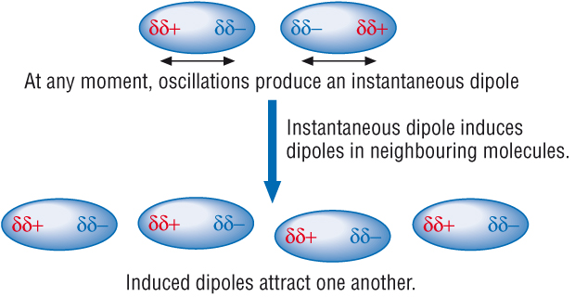

Even the noble gases, which exist as single atoms, have weak intermolecular forces due to van der Waals’ forces.

|  |  |  |
| --- | --- | --- |
| **Noble gas** | **Boiling point/oC** | **Number of electrons** |
| **He** | **-269** | **2** |
| **Ne** | **-246** | **10** |
| **Ar** | **-186** | **18** |
| **Kr** | **-153** | **36** |
| **Xe** | **-108** | **54** |
| **Rn** | **-62** | **86** |

**As the number of electrons increases, so does the strength of the dispersion forces.**

The boiling point increases as we move down the noble gas group.

***?*** *1. Describe how dispersion forces arise.*

Dispersion forces arise when electrons in a non-polar molecule

move to one side of the molecule at random. This causes the molecule

to have a temporary charge where the side with all the electrons

becomes slightly negatively charged and the other side slightly positively

charged. The negatively charged end can cause electrons in another

molecule to be repelled forming induced, temporary dipoles in that molecule as well.

This process is random and temporary.

*2. The boiling points of the group 7 elements are shown below.*

|  |  |  |  |  |
| --- | --- | --- | --- | --- |
| Element | F2 | Cl2 | Br2 | I2 |
| Boiling point/ °C | -188 | -34.7 | 58.8 | 184 |

*Explain this trend, in terms of intermolecular forces.*

Since these molecules are all non-polar, the only intermolecular forces

they undergo is dispersion forces. The strength of dispersion forces is

determined by the number of electrons in a molecule, the more electrons,

the stronger the dispersion forces. We can see that from fluorine to iodine,

the number of electrons in the molecules increase. This can be linked to the

rising boiling points due to the stronger dispersion forces. The stronger

dispersion forces hold the molecules together stronger meaning that they

are harder to break apart, thus the boiling point increases as the number of

electrons increase.

**2. Permanent dipole-dipole interaction**

* Polar molecules have permanent dipoles.
* The permanent dipole of one molecule attracts the permanent dipole in a different polar molecule to form permanent dipole-dipole force between those molecules.

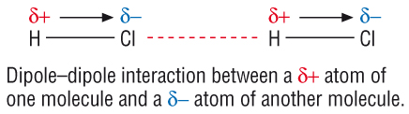

Molecules with **permanent** dipoles have stronger forces between molecules than molecules with **induced** dipoles.

HCl and F2 contain an equal number of electrons and should therefore have similar dispersion forces. The huge difference in their boiling points is due to HCl having a permanent dipole.

|  |  |  |
| --- | --- | --- |
| Substance | HCl | F2 |
| Boiling point/ ° C | -85 | -188 |

**3. Hydrogen bonding**

Hydrogen bonds are the strongest type of intermolecular force.

**Definition: A hydrogen bond is a strong dipole-dipole attraction between an electron deficient** **hydrogen atom attached** **to an electronegative atom (N, O or F), and the lone pair of electrons on a highly electronegative atom on a different molecule.**

**Hydrogen bonding between water molecules**

Hδ+ Hδ+

\ /

Oδ-||||||||||Hδ+ - Oδ-

/

Hδ+

***Exercise 11***

*Draw diagrams to show hydrogen bonding* ***between water molecule*** *and:*

1. *an* ***ethanol molecule***

H H Hδ+

| | /

H - C - C - Oδ-||||||||||Hδ+ - Oδ-

| | \

H H Hδ+

1. *an* ***ammonia molecule***

Hδ+ Hδ+

\ /

Hδ+ |> N:δ-|||||||||||Hδ+ - Oδ-

~~/~~

Hδ+

***Exercise 12***

*a) Draw a diagram to show hydrogen bonding between hydrogen fluoride molecules*

Hδ+ – Fδ-|||||||||Hδ+ – Fδ-

*Explain the trend in boiling points in the series: HCl, HBr, HI. Why is the boiling point of hydrogen fluoride, HF, out of the line in the series?*

|  |  |  |  |  |
| --- | --- | --- | --- | --- |
| Compound | HF | HCl | HBr | HI |
| Boiling point/ ° C | 20 | -85 | -67 | -35 |

The number of electrons in each molecule increases along the table. It is expected that with more electrons present in a molecule, the stronger the dispersion forces and therefore the higher the boiling point will be. While all the other molecules follow this trend, HF has a much higher boiling point than expected despite having the lowest number of electrons in the table. The reason for this is because fluorine is very electronegative causing HF to undergo hydrogen bonding which is much stronger than dispersion forces. This allows HF to have a much higher boiling point than expected.

***Exercise 13***

1. Urea is soluble in water due to the formation of hydrogen bonds between its molecule and water molecules. Urea is a solid at room temperature because of hydrogen bonding between the urea molecules.

(a) Complete diagram for urea molecule by showing all the lone pairs and permanent dipoles.



δ+

δ-



δ-

δ+

δ+

δ+



δ-



δ+



[3]

(b) Show a hydrogen bond between a water molecule and a urea molecule.

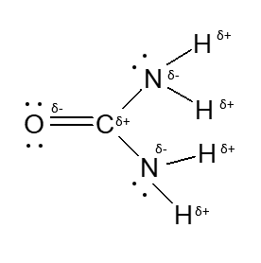

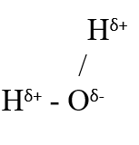



[3]

**Background reading**

**Rosalind Elsie Franklin** (1920 – 1958) was an English biophysicist and X-ray crystallographer who made important contributions to the understanding of the fine structures of DNA, viruses, coal and graphite. Franklin is best known for her work on the X-ray diffraction images of DNA which were an important influence on Crick and Watson’s 1953 hypothesis regarding the structure of DNA. When her work was published it represented evidence in support of their hypothesis. Later she led pioneering work on the tobacco mosaic and polio viruses.

She died at the age of 37 of complications arising from cancer of the ovary.

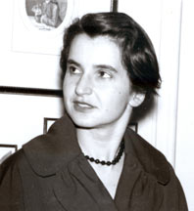

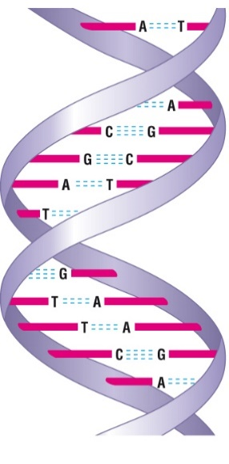

**Hydrogen bonding in DNA**

Hydrogen bonding occurs in organic molecules containing N-H groups - in the same sort of way that it occurs in ammonia. Examples range from simple molecules like CH3NH2 (methylamine) to large molecules like proteins and DNA.

The two strands of the famous double helix in DNA are held together by hydrogen bonds between hydrogen atoms attached to nitrogen on one strand, and lone pairs on nitrogen or an oxygen on the other one.

***Exercise 14***

*Complete a diagram by showing relevant dipoles, lone pair of electrons and hydrogen bonding between molecules of Adenine and Thymine.*

δ+

***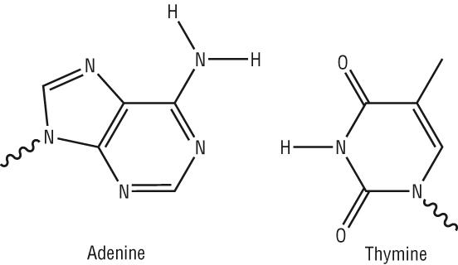***

δ-

δ-

δ-

δ+

δ+

**Physical properties of covalent compounds**

Most covalent compounds:

* have low melting points
* dissolve in non-polar solvents
* do not conduct electricity

***Exercise 15***

*Answer the following questions:*

1. *Why do most covalent compounds have low melting points?*

Most covalent compounds have low melting points due to the intermolecular forces that hold molecules together being rather weak.

1. *Name a covalent compound with a high melting point?*
2. *Covalent compounds often dissolve better in non-polar solvents than in water.*

*Give an example of a non-polar solvent.*

1. *Name a covalent compound that dissolves in water.*
2. *Name a covalently bonded substance which can conduct electricity.*

**The peculiar nature of water:**

Work in small groups to complete the following exercise

***Exercise 16***

*Property 1:*

*Explanation:*

*Property 2:*

*Explanation*

*Other properties:*

**bd14868_ The structure and density of ice**

*Use the following words to help you to complete the exercise about the structure and density of ice:*

*apart, free, permanently, less*

When water freezes, the water molecules are not \_\_\_\_\_\_\_ to

move about and hydrogen bonds form \_\_\_\_\_\_\_\_\_\_\_\_\_.

Ice has an open structure in which H2O molecules are further

\_\_\_\_\_\_\_\_\_\_\_\_\_ than H2O molecules in water. This leads to the

unusual situation in which ice is \_\_\_\_\_\_\_\_\_\_\_\_ dense than

water.

***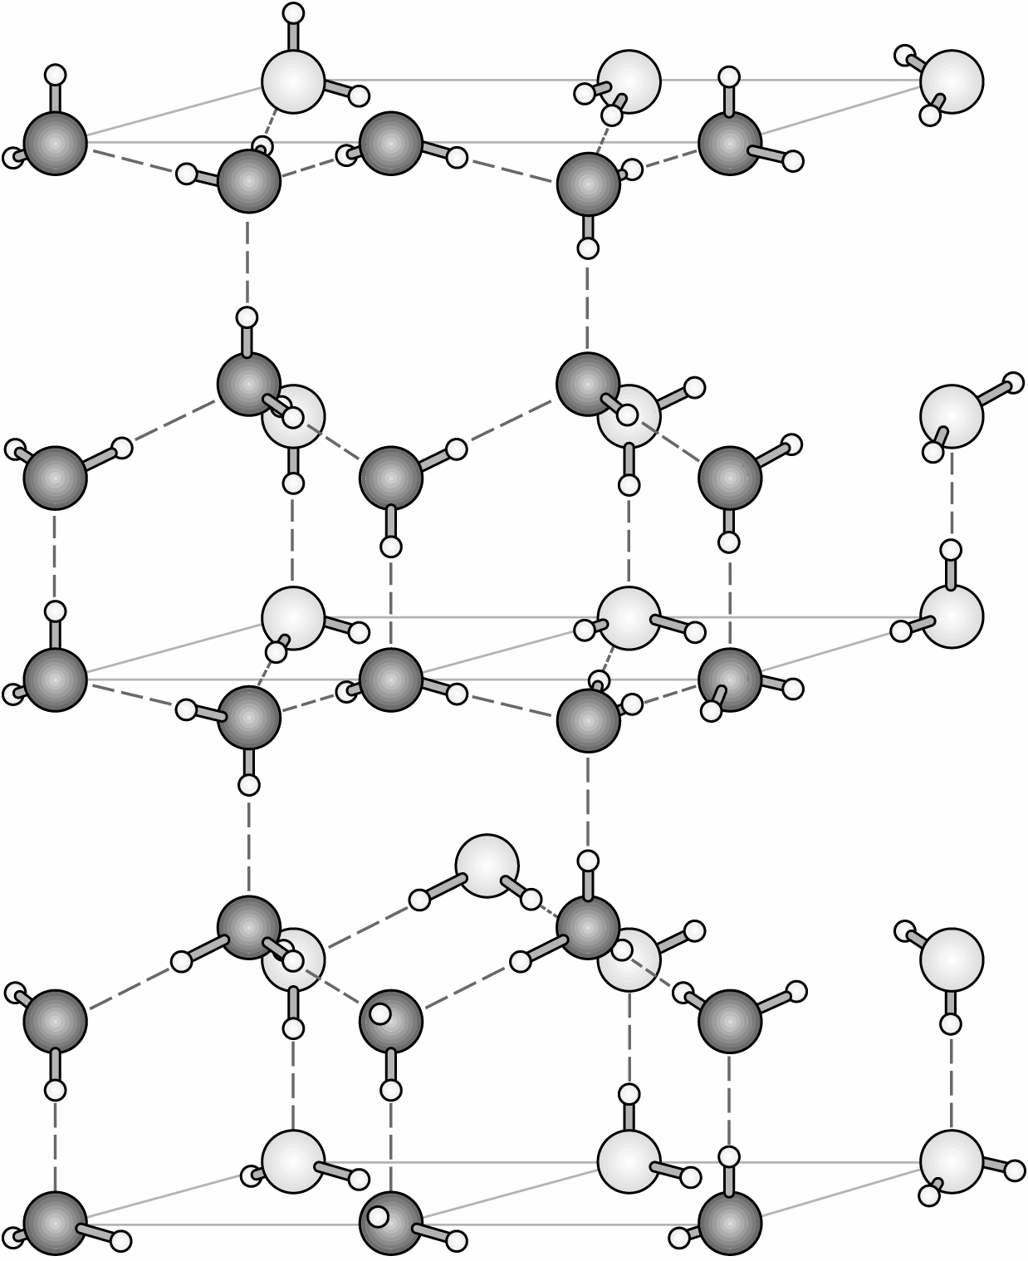***

**bd14868_ The boiling point of water**

**Hydrogen bonding accounts for the boiling point of water being much higher than expected for such a small molecule.**

Hydrogen bonds are extra-strong permanent dipole attractions that are much stronger than other intermolecular forces. **More heat energy needed to be supplied to overcome the strong intermolecular forces of attraction – hydrogen bonds.**

